‘Manipulated’ Stem Cells: How iPSCs have gone from Nobel Prize research to novel therapy reality

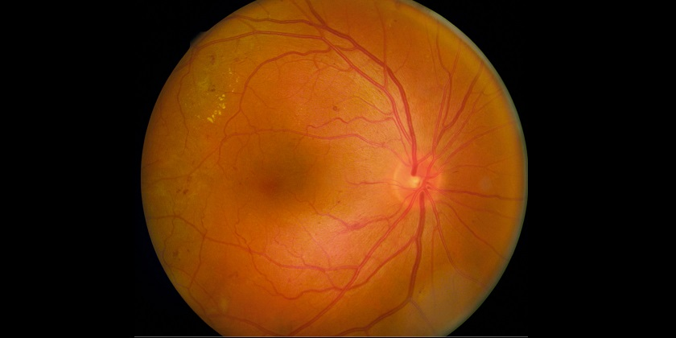

First patient to receive induced pluripotent stem cells in Japan to treat macular degeneration – is this a result of their regulatory modifications?
2006 saw the discovery that normal human adult cells could be ‘reprogrammed’ to become stem cells that could adopt the form of any type of cell, from heart to liver to skin. Fast-forward to this decade and not only has this pioneering research earned its discoverers a Nobel Prize (in 2012), but this week saw the announcement that this next-generation therapy will now finally be applied to patients within the coming days, after years of residing in labs.

Japan will play host to this inaugural clinical trial in which 6 patients, all suffering from an eye infliction called macular degeneration that would have eventually led to blindness, will receive induced pluripotent stem cells (iPSCs). This therapy will attempt to replace a damaged layer of cells located in their retinas.
This breakthrough comes at a time when discussions around Japan’s regulatory system for stem cell clinical trials are plenteous with questions coming from industry professionals from all corners of the global stem cell community as to the specifics of the changes:
- What regenerative medicine products will actually fall within Japanese legislation?
- What happens when companies need to scale up their manufacturing process elsewhere having previously trialled their product in Japan?
- What data will be accepted by the Japanese health authorities?
- How will other regulatory bodies need to adapt their national processes if companies go to Japan to commence testing?
- With regulations being challenging elsewhere, does Japan open doors to achieving mainstream cell therapies quicker?
- Are the successes with iPSCs and Japan’s alterations to its regulatory policy linked when one of the biggest hurdles elsewhere for iPSCs is regulatory?
Word on the cell therapy scene is that Japan’s proposed laws are to be finalised in November of this year so watch this space for updates… In the meantime what is your take on this potential policy game-changer and its impact of the stem cell and regenerative medicine sectors?

